**CS 450 Project 1**

**Kaiyuan Fan**

[fankai@oregonstate.edu](mailto:fankai@oregonstate.edu)

**Screenshot:**

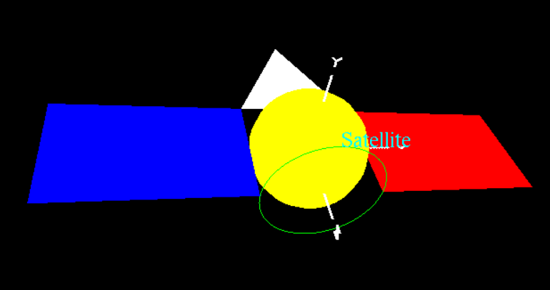

<https://media.oregonstate.edu/media/t/0_kypmgcgt>